

TOM Integration

Interface Specification
For
Stock Take Result

STORELINE
To
ORMS

[D029 to D021]

Project BEN Code: | W60416
Author: | Debasis Pattanaik
Date: | 22/02/2007
Version: | 0.3
Status: | Sign-Off
Modified By: | Debasis Pattanaik
Reviewed By:

Change Record

Author | Date | Version | Change Reference, description
Debasis Pattanaik | 19/02/2007 | 0.1D | Draft
Sankar G | 22/02/07 | 0.2D | Draft
Debasis Pattanaik | 23/02/2007 | 0.3D | Draft- Updated Erwin review comments

Reviewers

Name | Date | Version | Position
Ganesan, Sankar | 22/02/07 | 0.2D | Draft
Erwin Oguz | 23/02/07 | 0.2D | Draft

At least one reviewer is required.

Sign-Off

By signing this form, I understand and agree with the contents of this document.

Business Owner/Customer | Erwin Oguz
Position | Solution Architect
Signature
Date

Distribution List

Name | Date of Issue | Version
Oguz Erwin
David Onyett
Venkateswara Rao

Document Source

Related Documents: XML STORELINE source file schema, ORMS system TSD document & STORELINE system FSD document

Directory: Embedded in this document.

File Name:
STORELINE source file schema for reference from Turkey - tes.jp.retail.storeline.stocktakeRequest.v2.2.xml

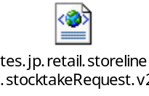

ORMS system TSD document - TSD008 - Stock Record - non-sales events.doc

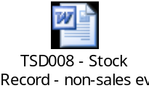

STORELINE system FSD document - FS1847_BO_Stock_Interfaces.doc

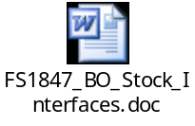

Information Architecture Context diagram
D029 D021- StockTake Result_Information_Context_Diagram.vsd

Mapping spreadsheet
D029 D021-StockTake Result - mapping document1.xls
Table of Contents
1 Introduction 7
1.1 Purpose of Document 7
1.2 Background 7
1.3 Scope 7
2 Description and Requirements for the End-to-End Interface 8
2.1 Description of the End-to-End Interface 8
2.2 Architecture 8
2.3 Requirements for the End-to-End Interface 9
3 Processing required in an Extract-Stage of the interface 10
3.1 Scope 10
3.2 Source Message Schema 10
3.3 Message Format 11
3.4 Message Transport Details 12
3.5 Naming and Configuration 12
3.6 Environment and Security Context 13
3.7 Non-Functional Requirements 13
4 Processing required in the Messaging Stage of the interface 14
4.1 Scope 14
4.2 Data Validation 14
4.3 Filtering 14
4.4 Mapping 14
4.5 Target Message Schema 14
4.6 Message Format 15
4.7 Message Transport Details 16
4.7 Naming and Configuration 17
4.8 Environment and Security Context 17
4.9 Non-Functional Requirements 17
5 Processing required in the <third stage of the interface> 18
5.1 Scope 18
5.2 Data Validation 18
5.3 Filtering 18
5.4 Mapping 18
5.5 Target Message Schema 18
5.6 Message Transport Details 18
5.7 Naming and Configuration 18
5.8 Environment and Security Context 18
5.9 Non-Functional Requirements 18
6 Testing Deliverables 19
7 Deployment 20
8 Assumptions and Outstanding Issues 21
8.1 Assumptions 21
8.2 Outstanding Issues 21
Appendix A Volumes 22
• Glossary 23
Appendix B Document Control 24

Introduction

Purpose of Document
The purpose of this document is to describe the interfacing requirements with respect to STORELINE interface (D029) Stock take result data updating into the ORMS system interface (D021).

The document is of a sufficiently technical in nature to allow a developer to build an actual interface. Additionally the document contains detail that might sit logically within a Technical System Design (TSD) document, but is contained here for expediency. Therefore the ORMS system Technical System Document (TSD) and STORELINE system Functional System Document are provided for better understanding of this interface.

This interface is only for US implementations. Turkey implementation does not require this interface.

Background
As part of Tesco Operating Model program, there is requirement to bridge the functionalities of enterprise applications including STORELINE and ORMS. To achieve this functionality, high level process flow architecture has been designed and approved by Tesco’s Enterprise Architecture team. As part of this process flow architecture there is a set of interfaces that has been identified to be developed to transfer Stock take result data from STORELINE into ORMS.

Scope
The Interface Specification covers:

- audit requirements across the interface
- security requirements across the interface
- timing/frequency requirements or constraints
- support requirements
- archiving
- the data format to be used for the interface at each stage (e.g. xml messages)
- the normal processing required at each stage
- recovery from failure required at each stage
- volumes.

Note that it is Tesco strategy to avoid placing any business logic in integration layer processing.

Description and Requirements for the End-to-End Interface

Description of the End-to-End Interface
The interface is to upload the Stock take result data from STORELINE interface D029 into ORMS interface D021. The Upload is a full upload in nature.

The interface will be governed by BizTalk Orchestration, which expects the Stock take result data in (| delimited flat file) from STORELINE interface (D029). The STORELINE interface will put this file (*.dat) in the shared location through RTI SOAP adapter. The BizTalk server then transfers this flat file data to a XML file which then transfer to ORMS through RIB in form of RIB messages. The transformation from BizTalk XML file to RIB message will be done through JMS adopter with the usage of RIB assembler. In turn RIB messages then publish those messages for subscription to update ORMS database in real-time basis. The transformations of XML file to RIB message determine the success/failure. In case of failure it will write into an error log file and does not require any archive process.

The interface will make use of the audit and traceability components that are being developed as part of the Operational Framework stream. Developers should put a ‘placeholder’ in their code / configurations as appropriate.

Architecture

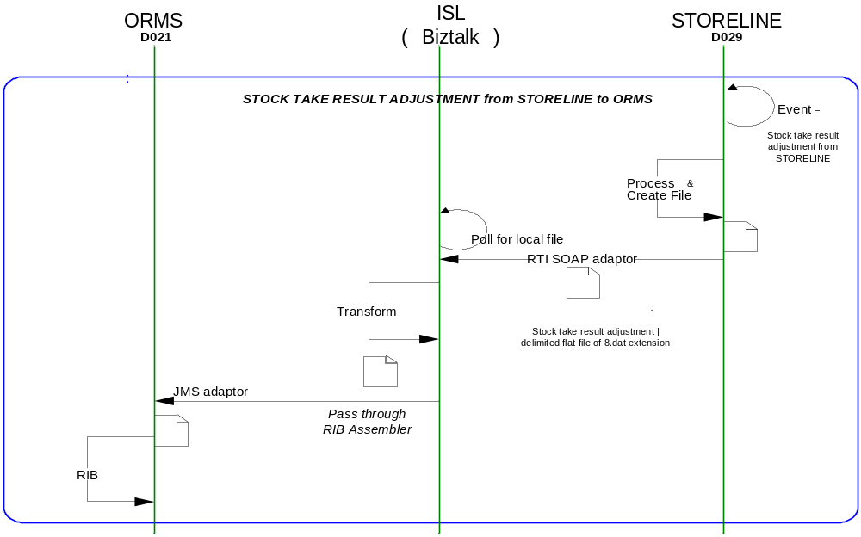

Requirements for the End-to-End Interface

Audit Requirements | The interface will use the components provided by the Operational Framework to satisfy audit requirements.
Security Requirements | The interface executes within a secure private domain. There are no additional security considerations required.
Timing/Cut-off Constraints | To be finalised.
Performance Requirements | The interface should be capable of extracting data in the form of flat file from the shared location at STORELINE side and delivering the resulting into ORMS side database tables before the identified cut-off time. The interface should run on real time basis.
Reliability and Availability Requirements | The interface-run should be atomic in nature. Where it is not possible to implement an atomic nature of interface, appropriate mechanisms should be in place to raise/alert appropriate parties.
Scalability Requirements | N/A - No scalability issues exist.
Operational Support Requirements | No such requirement has been agreed upon at the time of writing this document. However, it is perceived that there would be interface support requirements after go-live date that would require an evaluation.
Likelihood of Change Requirements | There is no such requirement
Cultural/Global Consideration Requirements | N/A
Legal Requirements | N/A
Compliance To Standards Requirements | No compliance exceptions.

Processing required in an Extract-Stage of the interface

Scope
STORELINE creates a pipe | delimited flat file whenever stock take has been taken and put the file in a dedicated shared location. The flat file extension is *.dat and BizTalk in turn picks up the file from the shared location and converts it to a XML file which in turn converted to RIB message through JMS adopter with the help of RIB assembler for update/insert of the underline table of ORMS.

Source Message Schema
Field Name | Optional | Type | Description
HEADER RECORDS
CapturedBy-CreatedBy | Yes | string | Extract file created user name
DateOfExtract | Yes | date | Store-line extraction date
DelAfterDate | Yes | string | Delivery before date
DelBeforeDate | Yes | string | Delivery after date
Description | Yes | string | Free form description
DriversName-Courier | Yes | string | Courier Driver Name
InvoiceNumber | Yes | string | Invoice Number
InvoiceTaxTotal | Yes | ui8 | Invoice Tax Total
InvoiceTotal | Yes | ui8 | Invoice Total
NoOfDetailLines | Yes | ui8 | No. of Detail Items
OrderDate | Yes | string | Count Order Date
OrderNumber-TransactionNo | Yes | ui8 | Count Order Number
OrderType-CountType | Yes | ui8 | Count Order Type
OriginalOrderNumber | Yes | ui8 | Original Order Number
ReasonCode | Yes | string | Reason Code
RecordType | Yes | string | Record Type
RefNo1 | Yes | string | Reference No 1
RefNo2 | Yes | string | Reference No 2
Remarks | Yes | string | Remarks
ReProcessedFlag | Yes | string | Re-Processed Flag
SelectionCriteria | Yes | string | Criteria of selecting extract data
SelectionRange | Yes | string | Range of selecting extract data
StocktakeDueDate | Yes | string | Date when stock take taken
StoreAddress | Yes | string | Location Address
StoreName | Yes | string | Location Name
StoreNo | Yes | ui8 | Location of extracted data
SupplierAddress | Yes | string | Supplier Address
SupplierCode-ToStore | Yes | string | Supplier Code
SupplierName |  | string | Supplier Name
SupplierType |  | ui8 | Supplier Type
TimeOfExtract |  | time | Extraction time of data
TotalQty |  | ui8 | Total Quantity
TotalValue |  | ui8 | Total Value
TransactionDateTime |  | string | Transaction Date and Time
UserName |  | string | Operator Name
DETAIL RECORDS – Grouping start(detail can have multiple record)
CountQty | Yes | ui8 | Stock count Quantity
DateOfExtract |  | string | Extract date of data
InvoiceCost-Excl-PerUOM | Yes | ui8 | Invoice cost per UOM
InvoiceQty | Yes | ui8 | Invoice Quantity
ItemDescription | Yes | string | Description of Item
ItemNumber |  | ui8 | Item Number
LineNumber |  | ui8 | Record Line Number(Record starts from 1)
Location | Yes | string | Location of extract item
OrderNumber-TransactionNumber | Yes | ui8
OrderQuantity-SentQuantity | Yes | ui8
OrderType | Yes | ui8 | Order Type
PackSize-Ratio | Yes | ui8 | Item Pack size
ReasonCode | Yes | string | Reason code of Item
RecordType |  | string | Record Type
ReferenceNo | Yes | ui8 | Reference No
SellingPricePerUOM | Yes | ui8 | Selling price per UOM
Sign | Yes | string | Sign indicator  - negative  + positive
StoreNo |  | ui8 | Store Id
SupplierItemNo-CatalogueNo | Yes | string | Supplier Item No
TaxPercentageOnCost | Yes | ui8 | Tax percentage on Invoice Cost
TimeOfExtract |  | string | Time of Extract
TrsCostPrice-Excl-PerUOM | Yes | ui8 | Transaction cost value excluding per UOM
UOMCode | Yes | ui8 | Unit of measure details
UOMDescription | Yes | string | Unit of measure description

Message Format
The source message is in the form of pipe | delimited flat file from STORELINE.

Message Transport Details

Feature | Specification | Additional Information
Source System Name | STORELINE
Source Platform / OS | IBM AIX
Source Physical Location
Source Underlying Data Storage Technology | SQL Server
Target System Name | Biztalk 2006
Target Platform / OS | Biztalk 2006 Server/Window Server 2003
Target Physical Location
Target Underlying Data Storage Technology | File Share
Transfer Function | HTTP (Put/Post) □  HTTPS (Put/Post) □  Message Queue □  FTP □  SOAP/Web service ☑  (XCOM) □
Data Format. | XML □  Delimited ☑  Positional □ | | delimited
Decryption/Encryption | No
Decompression/Compression | No
Transmission Mode | Synchronous □  Asynchronous ☑  Bulk Data □
Real-time/Scheduled Batch | Not yet decided
Archiving | There is no requirement to archive the messages.
Logging | Logging should occur, such that the message can be recreated if necessary.
Error Handling | Not yet decided  Processing should prevent sending of duplicate messages, unless this occurs during recovery from failure.

Naming and Configuration

Biztalk – 2006
Package Name: TOM.D029 to D021 Integration STOCK TAKE STORELINE to ORMS
BizTalk Procedure
Name | TOM.D029 to D021 Integration STOCK Take STORELINE to ORMS
<Placeholder for other package components/steps>
<Placeholder for other package components/steps>

The naming standard to be followed as mentioned in this document –

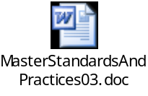

Environment and Security Context
Account details will be included here once we have visibility of the environments.

Non-Functional Requirements
Not Applicable

Processing required in the Messaging Stage of the interface

Scope
The interface is meant to run at a pre-configured time interval, which on completion is expected to produce a XML file (containing reference data records) onto the shared location. The XML file will pass through RIB assembler and transferred to ORMS location through JMS adaptor. This shared location would be monitored by ORMS systems Interface at the same interval. Once the file containing the extracted data appears on the shared location it should load the data (updates/inserts) into ORMS using RIB.

Data Validation
Data Validation will be done by the target ORMS system.

Filtering
There is no filtering requirement.

Mapping
Mapping document will be provided subsequently.

Target Message Schema
Target Message Schema in XSD format before it passed on to RIB assembler:
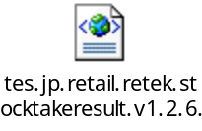
The Description of the fields as mentioned in the XSD file:

Record  Name | Field Name | Field Type | Start Pos | End Pos | Description
URL | URLToken | Char | 1 | 300 | The target File name → “FILE=tsc_disprtvupld_{Store No}_yyyymmddhhmmss_{system date to millisecond fraction}”
FileHdr | CreateDate | Date | 20 | 27 | setHdr→DateofExtract
FileHdr | CreateTime | Time | 28 | 33 | setHdr→TimeofExtract
FileHdr | CycleCountId | Char | 48 | 55 | setHdr→RefNo1
FileHdr | FileLineNumber | Number | 6 | 15 | Sequential line number in the file
FileHdr | FileTypeDefination | Char | 16 | 19 | Constant Value- “STKU”
FileHdr | Location | Number | 57 | 66 | setHdr→StoreNo
FileHdr | LocationType | Char | 56 | 56 | Constant Value- “S”
FileHdr | StockTakeDate | Char | 34 | 47 | setHdr→StockTakeDueDate
FileDtl | FileLineNumber | Number | 6 | 15 | Record No +1
FileDtl | InventoryLocationDescription | Char | 56 | 85 | setDtl→StoreNo
FileDtl | InventoryQuantity | Number | 44 | 55 | setDtl→CountQty
FileDtl | Item | Char | 19 | 43 | setDtl→ItemNumber
FileDtl | ItemType | Char | 16 | 18 | Constal Value- “ITM”
FileTrlr | FileLineNumber | Number | 6 | 15 | Detail record count incremented to step 1.
FileTrlr | NumberOfFileDetailLines | Number | 16 | 25 | Detail record count decremented to step 2.

Message Format
The source message is a pipe | delimited flat file from STORELINE and is getting converted into the target file format for ORMS in a package. The target message is a XML file. This file again mapped in RIB assembler for conversion of a RIB message.

4.7 Message Transport Details
For messages destined for RIB system, the following applies.

Feature | Specification | Additional Information
Source System Name | BizTalk 2006
Source Platform / OS | BizTalk 2006 Server – Windows server 2003
Source Physical Location
Source Underlying Data Storage Technology | File System
Target System Name | RMS, RWMS
Target Platform / OS | IBM AIX
Target Physical Location
Target Underlying Data Storage Technology
Transfer Function | HTTP (Put/Post □  HTTPS (Put/Post) □  Message Queue □  FTP □  File Drop (Windows) □  (XCOM) □  JMS Adapter ☑
Data Format | RIB Message ☑  XML ☑  Delimited □  Positional □
Decryption/Encryption | No
Decompression/Compression | No
Transmission Mode | Synchronous □  Asynchronous ☑  Bulk Data □
Real-time/Scheduled Batch | Real-time
Archiving | There is no archiving requirement
Logging  Should logs be kept of all actions? For how long should these be stored? | Logging should occur, such that the message can be recreated if necessary.
Error Handling | Not yet decided  Processing should prevent sending of duplicate messages, unless this occurs during recovery from failure.

Naming and Configuration

Biztalk 2006
Instruction Name:
Instruction Details
Description | To be determined
Enabled | True
Type
Operational Window
Schedule | N/A
Enabled | False
Host Details
Account | To be determined
Operational Details
Worker Threads
Priority
Batch Size
Period
Retry Attempts
Timeout
Require Data Send
Exception Management
Treat Fatal Adapter Exception As
Treat Unhandled Exceptions As

Environment and Security Context
Account details will be included here once we have visibility of the environments.

Non-Functional Requirements
On successful delivery of the file to the target system, the audit log should be updated via the Operational Framework pipeline component or adapter (to be determined).

In the event of a failure the file should be written to the failed files location, and an alert should be raised.

Processing required in the <third stage of the interface>

Scope
There is no intermediate staging is required for this interface. So this section is not applicable.

Data Validation
Not Required

Filtering
Not Required

Mapping
Not Required

Target Message Schema
Not Required

Message Transport Details
Not Required

Naming and Configuration
Not Required

Environment and Security Context
Not Required

Non-Functional Requirements

Not Required

Testing Deliverables
Unit Test Scripts and test cases are kept at the following location <location>

Deployment

Assumptions and Outstanding Issues

Assumptions
ID | Assumption
1 | Rollback transaction supported by ORMS in case of failure.

Outstanding Issues
ID | Issue | To be addressed by
2 | Error handling | Erwin Oguz
3 | Error log file location need to de defined | Erwin Oguz
4 | STORELINE source file Physical Location need to be defined | Erwin Oguz

- Volumes
- Glossary

Acronym | Term | Description
EAI | Enterprise Application Integration | The process of meeting the data requirements of applications by providing a message based transport from disparate data sources across all forms of enterprise technology.
EAI Layer | Enterprise Application Integration Layer | Refers to the integration services provided to implement EAI. In contrast to the EIA Layer for data services. See below.
EIA | Enterprise Information Architecture | Creation of a strategic single view of data across the enterprise.
Interface | Interface | Many definitions exist for 'interface'. In general, 'interface' refers to the link between a data source and a data target. And there are properties of the interface in this context. However more specifically 'interface' refers to one end of a data link, hence the terms source interface and target interface, and both the source interface and the target interface will have specific properties of their own.
ORMS | Group Forecasting and Ordering | The ORMS operates on Tesco deals with the forecasting & Ordering.
STORELINE | STORE used for inventory purposes. | The STORELINE operates on Tesco deals with the inventory control.
XSD | XML Schema Definition | It describe the elements in an Extensible Markup Language (XML) document
XML | Extensible Markup Language | An open standard for describing data. It is used for defining a common method for identifying data. It supports business-to-business transactions and also uses electronic data interchange and Web services.
FTP | File Transfer Protocol | The Internet File Transfer Protocol (FTP) is defined facilities for transferring files to and from remote computer systems.
RIB | Retek Integration Bus | This is an integration Interface between the Oracle Retek modules.
RIB Assembler | Retek Integration Bus Assembler | This is a custom code written for TESCO Integration Model to post the RIB message is a required format which is required by RETEK systems. This assembler will convert the XML message with the mapping elements into RIB message.

- Document Control
Change Record

Author | Date | Version | Change Reference, description
Debasis Pattanaik | 19/02/2007 | 0.1D | Draft
Sankar G | 22/02/07 | 0.2D | Draft
Debasis Pattanaik | 23/02/2007 | 0.3D | Draft-Updated Erwin review comments

Related Documents

Author | Date | Version | Title
Isaac | 18-Aug-2004 | 4.0 | StoreLine FS1847 – BO Stock Interfaces
Neil Williams | 26-Jan-2007 | 0.02 | Technical System Design - TSD008 Stock Record - non-sale events

Distribution

Name | Position | Approver/Contributor/Other
Erwin Oguz | Enterprise Architect | Approver
David Onyett | Project Leader
Venkateswara Rao | Offshore Co-ordinator

